
Kaunas University of Technology
Faculty of Informatics
Input & output analysis. KNN. Decision tree. Random forest.

Evans Weerawardene
Project author
prof. dr. Dalia Čalnerytė
Supervisor
Kaunas, 2025
Table of Contents
List of figures 3
List of tables 4
Introduction 5
1. Data Quality Report 6
1.1. Determination of Feature Types 6
1.2. Data Quality Analysis 6
1.2.1. Missing Values 6
1.2.2. Visualizations of Numerical and Categorical Features 6
1.3. EDA Report 8
1.4. Justification of Preprocessing Decisions 9
2. Properly Preprocessed Continuous Data with Visualized Results 11
2.1. Preprocessing Step: Standardization 11
2.2. Visualizations: Before and After Standardization 11
2.2.1. Square_feet distribution 11
2.2.2. Price distribution 12
2.2.3. Commentary 12
3. Selected Interpretable Metrics for Result Evaluation 13
3.1. Evaluation Metrics 13
3.2. Model Performance Summary 13
4. Analysis of Data Preprocessing Steps 14
5. Comparison with Benchmark 15
5.1. Model Comparison against Benchmark 15
6. Software Implementation 16
Conclusions 17
List of information sources 18

List of figures
Figure 1 Histogram Plot 7
Figure 2 Box plots 7
Figure 3 Bar Plots 8
Figure 4 Distribution of square_feet (after standardization) 11
Figure 5 Distribution of Price after Standardization 12

List of tables
Table 1 : Report for numerical data…………………………………………………………… 9
Table 2: Report for categorical data…………………………………………………………… 9
Table 3: Summary of the performance of each model………………………………………… 13
Table 4: Model performance comparison against benchmark.................................................... 15

Introduction
This report outlines the process of exploring and modeling a dataset of apartment rental postings so that accurate rental price predictions could be obtained. Analysis starts with a proper data quality check, leading to a justified set of preprocesssing choices. Three independent machine learning algorithms, K-Nearest Neighbors, Decision Tree, and Random Forest, are subsequently trained, validated, and compared against a naive baseline to determine the best-performing model on this prediction task. Preprocessing choices as well as the quality of the ultimate implementation are also addressed.

Data Quality Report
This section provides a detailed description of the data quality of the apartment rental data set. The analysis involves feature types, data quality report, visualization, and descriptions of preprocessing choices.

Determination of Feature Types
The dataset contains a mix of categorical and numerical features.
- Numerical Features : Represents quantitative measurements. The features that are numeric are (price, bathrooms, bedrooms, square_feet, latitude, longitude & time).
- Categorical Featues: Represents qualitative data that can be grouped. The following features are categorical (category, amnities, currency, fee, has_photo, pets_allowed, price_display, price_type, cityname, address, state, source).

Data Quality Analysis
A comprehensive exploratory data analysis was done to explore data distribution patterns identify potential problems such as missing values, outliers.

Missing Values
The following columns in the data set contained a significant proportion of missing values.
- address : 92.04%, pets_allowed : 60.74% and amneties: 16.11%
All of the other columns had missing values less than 1%.

Visualizations of Numerical and Categorical Features
Numerical Features

Histograms and box plots were used to plot numerical features.

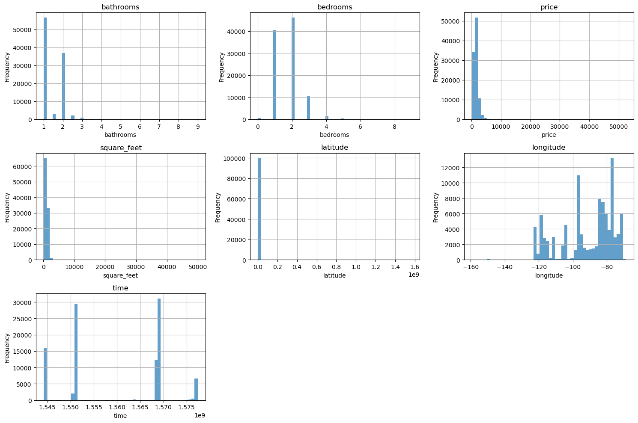

Figure 1 Histogram Plot
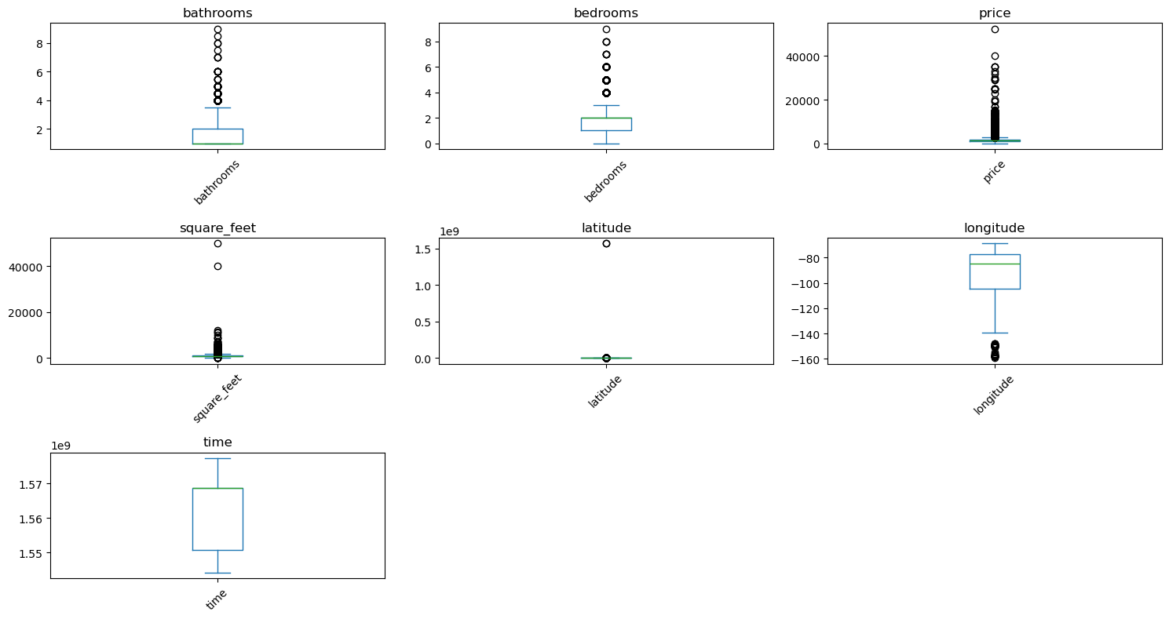
Figure 2 Box plots

From the plots we could deduce that the majority of households have 1 or 2 bedrooms and bathrooms and very few has more. The histograms for price and square_feet are heavily right skewed indicating that most properties have a lower price and smaller square footage. Also the distributions for latitude and longitude are multimodal.

Categorical Features

Barplots were used to plot categorical features.

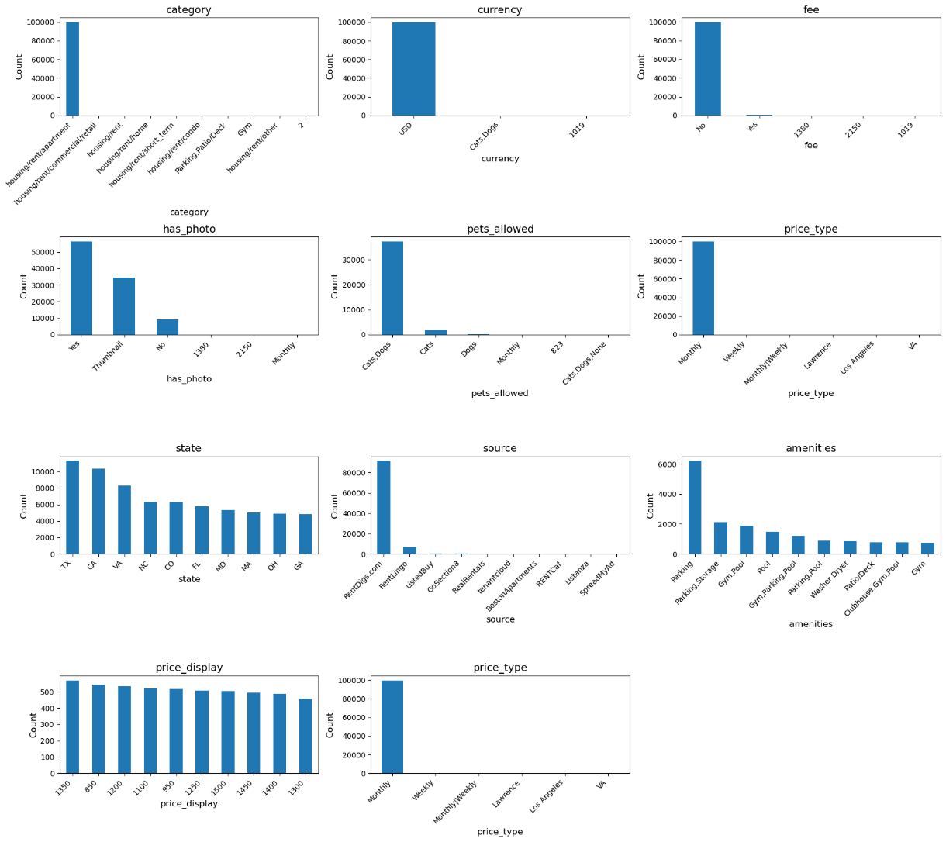
Figure 3 Bar Plots
From the plots we could deduce that photos are available for a large number of houses and also the major category is “housing/rent/apartment”.

EDA Report
The EDA Report for numerical and categorical data is as follows.

Table 1. Report for numerical data
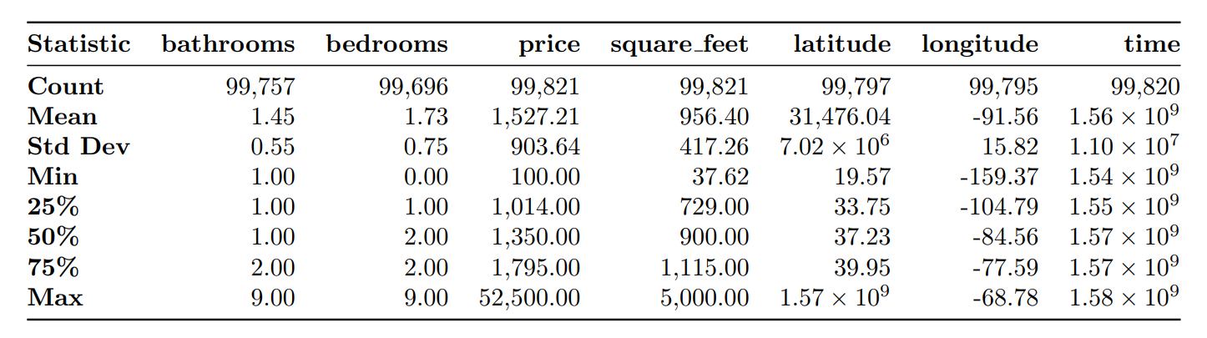
Table 2: Report for categorical data
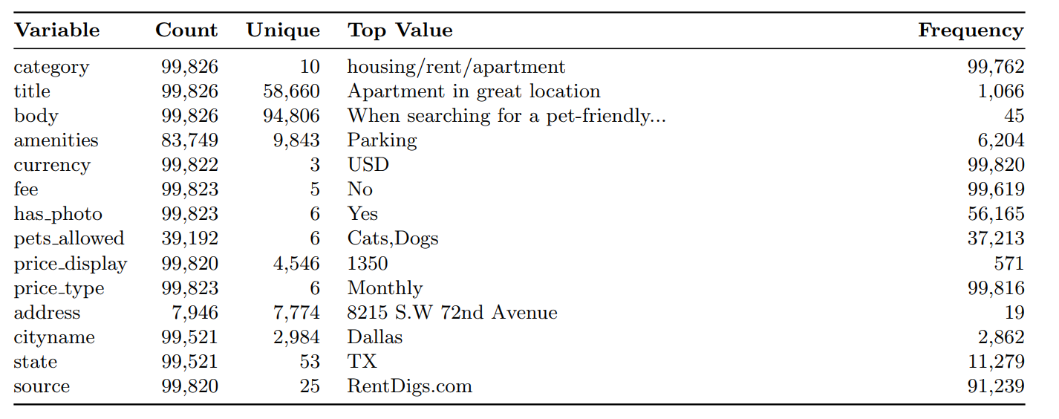

Justification of Preprocessing Decisions
According to data quality analysis results, the following preprocessing decisions were made:

Dropping High Missing Percentage Columns: The address and pets_allowed columns were dropped from the data set.

- Reasoning: The address column contained over 92% of its values missing, and pets_allowed contained over 60%. It would be extremely likely to add noise and bias to the model trying to fill in this amount of missing data. The geographical position is already being depicted by the latitude and longitude columns, and therefore the address column is somewhat redundant when modeling. As a result of the presence of a lot of missing data, removing these columns was the most practical and methodologically sound thing to do to ensure the integrity of the dataset.
2. Deletion of Unstructured Text and Duplicate Columns: The title, body, and source columns were removed.
- Justification: The title and body columns contain unstructured text data. While these might be used for higher-order analysis by Natural Language Processing (NLP), in this project's context, to cover structured data, they are not necessarily directly implemented in their raw state to the chosen regression models. The source column, employed to identify the website of listing, is also not considered a primary predictor of rent price for an overall model and was therefore removed to keep the feature set at a minimum. This is done to reduce the dimensionality of the dataset and focus more on more structured and easily applicable features for price prediction.

Properly Preprocessed Continuous Data with Visualized Results
To be effective for some algorithms of machine learning (especially distance-based ones like K-Nearest Neighbors) the continuous numerical variables in the dataset had to be preprocessed. Standardization was the most critical step utilized during the preprocessing.

Preprocessing Step: Standardization
Standardization was carried out through the help of StandardScaler from the scikit-learn library. It shifts the data so that the mean is 0 and the standard deviation is 1. ths step is important as it stops features that have bigger scales (like price or square_feet) from taking over the learning procedure of the model over features that have smaller scales (like bathrooms).

Visualizations: Before and After Standardization
Here, we visualize the distributions of square_feet and price before and after applying StandardScaler.

Square_feet distribution
Before Standardization: The distribution of square_feet is heavily right-skewed, with most values concentrated on the lower end (under 5,000 sq ft) and a long tail of outliers representing very large properties.

After Standardization: After standardization, the shape of the distribution remains the same (still right-skewed), but the scale on the x-axis has changed. The mean is now centered at 0, and the values are expressed in terms of standard deviations from the mean.

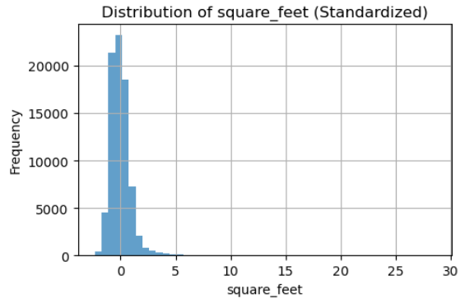
Figure 4 Distribution of square_feet (after standardization)

Price distribution
Before Standardization: Similar to square_feet, the price distribution is also right-skewed, indicating that most rental prices are clustered at the lower end, with fewer, more expensive properties creating a long tail.

After Standardization: The standardized price distribution is centered at 0. This transformation ensures that the scale of the price does not disproportionately influence the model's predictions during training.

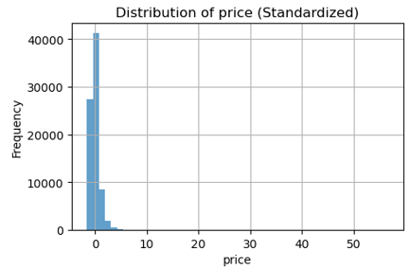
Figure 5 Distribution of Price after Standardization

Commentary
These visualizations clearly signify that standardization doesn't change the distribution shape of the data, rather scales it. It is a very necessary step for making all the numerical features contribute equally during the learning process of the model so that it results in stable as well as consistent performance.

Selected Interpretable Metrics for Result Evaluation
Three regression models were trained, i.e., K-Nearest Neighbors (KNN), Decision Tree (DT), and Random Forest (RF). All the models were then measured on Mean Absolute Error (MAE), Root Mean Squared Error (RMSE), along with R-squared (R²). Hyperparameters optimally suited to each model were determined during GridSearchCV.

Evaluation Metrics
MAE: Calculates the mean absolute difference between actuals and forecasts.
RMSE: Places more emphasis on big errors.
R²: measures the amount of variation that the model covers (the closer to 1, the better).

Model Performance Summary
This table holds the test set results on the best instance of each model as discovered during the search process on the hyperparameters.
Table 3: Summary of the performance of each model
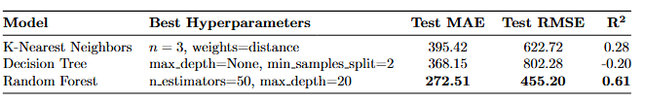
Random Forest clearly produced the best results. Decision Tree strongly overfit the training data, causing very poor generalization and a negated R² value on the hold-out set. KNN provided a small gain over a naive baseline, but the Random Forest was considerably more accurate, accounting for 61% of the variance in rent.

Analysis of Data Preprocessing Steps
Data preprocesssing is an indispensable step that significantly influences the performance of the model. Here, we discuss the significance of three most important preprocesssing steps.

Feature Scaling (Standardization):

Significance: We needed to standardize numerical features, even more so the K-Nearest Neighbors algorithm. KNN operates based on the calculation of distances (i.e., Euclidean distance) between points. If the features are scaled differently, the feature that undergoes the most scaling will dominate these calculations, and the algorithm will be unable to learn the true relationships between the data.

Impact: Without standardizing the square_feet feature, which has such a wide range of numbers, it would otherwise had a much larger impact than the bathroom or bedroom features on the distance metric. By standardizing all numerical features so that they encompass a mean value of 0 and a standard deviation value of 1, we ensure that each feature has an influence on the model predictions proportionally, so that a more accurate and reliable KNN model emerges. Tree-based algorithms like Decision Trees as well as Random Forests are less reliant on scaling the features, although still a recommendation.

Deleting Columns Which Have Large Missing Values:

Significance: We also excluded the address (92% missing) and pets_allowed (61% missing) variables. It would have necessitated the imputing of an astronomical number of missing values to keep those variables.

Impact: It would likely add a great amount of noise and bias to impute this high proportion of missing data. As an example, substituting pets_allowed with the most common value would establish a false majority and possibly fool the model. Dropping these columns minimizes the opportunity for the model to learn patterns based on false data, making the model stronger and more general. The important location data was retained with the latitude and longitude features, which had very little missing data.

One-Hot Encoding of Categorical Features:

Significance & Impact: The machine learning algorithms need numerical inputs. Category, fee, and price_type are categorical variables that are provided as text, so they needed to be converted into a numerical dataset. One-hot encoding stepped up. Effect: It generates new binary columns that are created once for each category that is present in a feature. Omitting this step, the models could not process the categorical data, so the execution would fail. If we used any other technique, such as label encoding (giving an integer to each category), the model would potentially falsely assume an ordinal relationship between the categories (such as that category 2 is "greater" than category 1), which is incorrect for nominal data. It prevents this problem altogether, so one-hot encoding enables the model to learn the separate contribution of each category, making it an important step to properly include categorical information.

Comparison with Benchmark
To evaluate the effectiveness of the trained models, their performance was compared against a simple benchmark. The benchmark model predicts the average rental price from the training data for every instance in the test set.
- Average Price in Training Set: $1526.22
- Benchmark Prediction (for all test instances): $1526.22

Benchmark Performance on Test Set:
- Test MAE: $545.58
- Test RMSE: $901.89
- Test R²: -0.0000

Model Comparison against Benchmark
Table 4: Model performance comparison against benchmark.
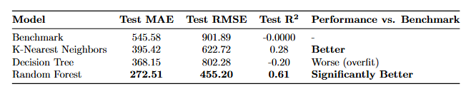
The Random Forest model performed significantly better than the benchmark, reducing the Mean Absolute Error by nearly 50%. The KNN model also provided an improvement. The single Decision Tree, due to overfitting, performed worse than the simple average benchmark on the test set, highlighting the importance of using more robust models like Random Forest.

Software Implementation
It was executed through a Pipeline and ColumnTransformer from scikit-learn. This structure allows the whole process—the data preparation, the model building—to be wrapped into a single entity.
- Handling New Data: This implementation is robust for handling new, unseen data in its original format. When new data is passed to the trained pipeline for prediction, it automatically undergoes the exact same preprocessing steps that were applied to the training data.

- The same numerical features (bathrooms, square_feet, etc.) are standardized using the standard deviation and mean derived from the initial training set.

- Same categorical features are encoded as one-hots according to the categories learned during the initial training set. If there is any unseen category that wasn't included in the training data, the handle_unknown='ignore' parameter takes care of this so that it doesn't lead to an error.

- The preprocessed data is then passed to the trained model (Random Forest, etc.) to predict.

This method prevents data leakage and guarantees that the preprocessing is used consistently, so the model becomes dependable for use in a real-world situation where the data that it would be given would be new.

Conclusions
This analysis was successful in demonstrating a full machine learning pipeline for forecasting rental prices. Primary issues related to data quality, including high rates of missing data as well as skewed distributions within features, were recognized and handled through multiple processing steps. Comparison among three various models revealed that the Random Forest model was an exemplary selection for this task, as it obtained a Test R² value of 0.61, substantially higher than the K-Nearest Neighbors model, the over-fit Decision Tree, as well as the baseline benchmark. The finished implementation, constructed within a pipeline within the scikit-learn package, guarantees that the data cleaning as well as modeling procedure is stable, replicable, as well as ready to be implemented on new data.

List of information sources
- scikit-learn: machine learning in Python — scikit-learn 1.7.2 documentation

